# Worksheet 1 – Using Visual Studio Architecture Models

This worksheet will teach you how to get started with Visual Studio Modelling Projects and draw Use Case Diagrams.

1. **Creating a Modelling Project**

Start Visual Studio 2012 (Ultimate Edition).

Select **File – New Project – Modelling Projects**

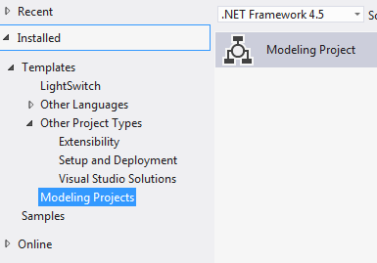

Give the project a sensible name and click OK. A Blank Modelling Project will be created.

First make sure the Toolbox is visible. If it isn’t, enable it by clicking the selector and adding it.

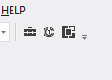

1. **Drawing a Use Case Diagram**

From the menu select: **Project – Add New Item.**

A list of available UML diagram types is displayed. We are going to start with a Use Case Diagram

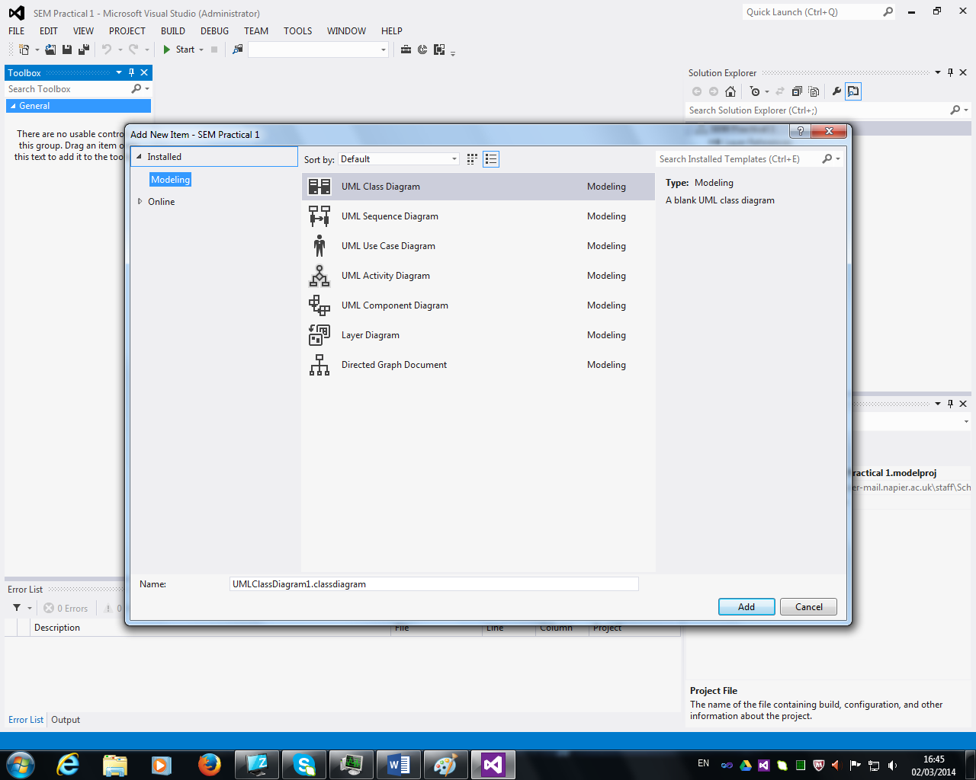

Using the tools from the toolbox draw a Use Case Diagram for the following scenario:

A Doctor’s surgery has a computer system that manages the practice. The Receptionist uses the system to make appointments for patients, either by telephone, email or when they have been in to see the doctor. The Doctor uses the system to record patients treatments and this sometimes includes writing a prescription. When a doctor writes a prescription he/she always checks the correct dosage

3 Understanding UCDs



Write a brief description of the use case above here:

The junior in this hairdressers system makes appointment, maintains the product list, sells products and handles customer payments. When he/she maintains the product list or sells product they must find the product every time.

The manager is in charge of maintaining the staff list.